

**Exhibition Entry Form**

Contact ______________________ Phone _________________________

Address ____________________________________________________________

Email ___________________________________

Date __________________________

Brief Description of Your Work:

_______________________________________________________________________

______________________________________________________________________________

______________________________________________________________________________

______________________________________________________________________________

**Mission:** The goal of the Union Hall Gallery is to mix labor, education, and art in a manner that will speak to the experiences of the community and the world around it.

**Please note that viewing hours are limited to second Saturday (6­–9pm) and by appointment only.**

**The Gallery designs / prints cards and lists exhibits on internet (including social media) sites to promote shows.**

**Goal**: we are enthusiastic about showing work that supports LRCCD employees and student or represents union core values, or both. Please explain if your work relates to our mission.

_______________________________________________________________________

_______________________________________________________________________

_______________________________________________________________________

**Submission Process**: submit up to five digital images (JPG) of either representative works of actual works you hope to have selected for exhibiting. Digital images should be approximately 8” x 10” and at least 1 MB. Name each JPG with your first initial, last name and image number (example: JSmith1.jpg, JSmith2.jpg, JSmith3.jpg). Along with the JPGs, complete and submit the Application Form to identify titles, media, sizes, dates made. Identify which pieces are available and which are representative of your work. Write a short narrative for each piece (optional). Write up to a 250-word narrative about the body of work and your work as an artist and activist. Submit all material in a single zip file with your name.

**Send all submissions to** gallery@lrcft.org

It is imperative that the artist look carefully at the space on a Second Saturday previous to exhibiting, to see constraints of hanging system, size, space, available pedestals. Work not fitting constraints will not be hung.

**Restrictions**: artwork must not exceed 80 lbs and the height must not exceed 6 ft for all walls with the exception of A, B, and C walls which are a max of 4 feet. (see floor plan on next page)

All submitted works will be considered by the Gallery Advisory Committee members. A scoring system will be used to evaluate the submissions on the following criteria:

* Artistic quality
* Strength of written narrative in art and activism
* Personal dedication to the cause of public awareness

All artists who submit work for consideration will be notified of the Committee’s decision within 60 days.

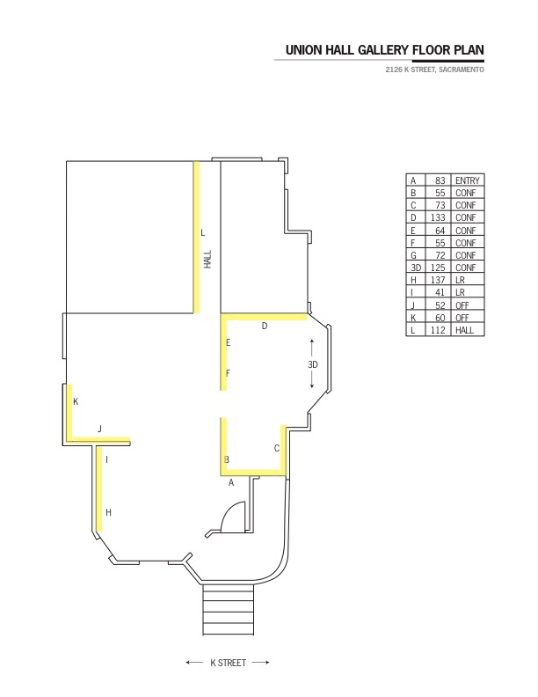

Yellow highlights indicate walls for hanging artwork